Stop Aquatic Invaders in Our Neighborhood!

Author: Erica Sprague, Meridian Junior High School
Target Grade: Middle School Science (6-8)
Topic: Invasive Species
Time: 2-3 (60 minute) class periods (longer if teacher wishes to do presentations in class)

Lesson Overview:
Students will be challenged with helping a local homeowners association on a private lake develop and implement a plan for keeping aquatic invasive species out of their lake when it opens up to public use this spring. The lesson guides students through the challenge of helping people understand what invasive species are and how to identify them, how to create guidelines for keeping them out of the lake and what to do if an invasive species is spotted. This lesson will focus on three different invasive species to look out for.

Sources Consulted:
- Michigan DNR: Eurasian Milfoil
- Michigan DNR: Quagga Mussels
- Michigan DNR: Rusty Crayfish

Arresting the Spread of Eurasian Watermilfoil (Myriophyllum spicatum) in the Great Lakes
- Critter Catalog: Rusty Crayfish
- Mussels destroying link in Lake Michigan food web

Learning Objectives:
After the lesson, students will be able to…
- Define invasive species
- Identify 3 common aquatic invasive species and explain how they can harm a lake ecosystem
- Create a presentation and infographic handout for local homeowners who live on the lake to help them understand the effects of aquatic invasive species, how to identify them, how to keep them out of the lake and what to do if they are spotted.

Michigan Science Standards Addressed:
SEP: Science and Engineering Practices
- Asking questions and defining problems
- Constructing explanations and designing solutions
- Obtaining, evaluating, and communicating information
DCI: Disciplinary Core Ideas
- MS-LS2-1 Analyze and interpret data to provide evidence for the effects of resource availability on organisms and populations of organisms in an ecosystem.
- MS-LS2-3 Develop a model to describe the cycling of matter and flow of energy among living and nonliving parts of an ecosystem.
- MS-LS2-4 Construct an argument supported by empirical evidence that changes to physical or biological components of an ecosystem affect populations.
CCC: Cross Cutting Concepts
- Cause and Effect
- Stability and Change

Michigan Social Studies and ELA Standards addressed:
Social Studies Process and Skills Standards: Grades 6 - 8
P3 PUBLIC DISCOURSE AND DECISION MAKING
P3.1 Clearly state an issue as a question of public policy, gather and interpret information about that issue, and generate and evaluate possible alternative resolutions.
P3.3 Construct arguments expressing and justifying decisions on public policy issues supported with evidence.
ELA Standards
- Write informative/explanatory texts, including scientific … or technical processes.
  - Introduce a topic clearly, previewing what is to follow; organize ideas, concepts, and information into broader categories as appropriate to achieving purpose; include…graphics and multimedia when useful to aiding comprehension.
  - Develop the topic with relevant, well-chosen facts, definitions, concrete details, or other information and examples.

List of Materials:
- Computer access to links or printed articles.
- Infographics can be done on construction paper if computers are not available (markers, scissors, glue, etc. may be used)

Room Arrangement or Special Needs
Students are grouped together for the activities and lab (3-4 students max).

New Vocabulary
Non-Native Species: Species that have been introduced into an ecosystem that they have not historically been a part of (synonyms: alien species, nonindigenous species, introduced species)

Invasive Species: A non-native species in an ecosystem that may cause harm to the economy, the environment or human health.

Food Web: A system of interconnected and interrelated food chains

Infographic: a visual image such as a chart or diagram used to represent information or data

5E Model Lesson Plan

Engage - Guiding Question: How can our local homeowners association work together to stop invasive species from getting into our private lake once it is open to the public? Students are faced helping to solve this problem. A group of homeowners on a private lake want to make sure that their lake stays invader free once it becomes open to the public. They are opening a public boat launch and dock next spring. The association has asked students to present information to the people who currently live on the lake to help them understand invasive aquatic species, why we need to keep them out, how to identify them, etc. Students are also being asked to create infographics for homeowners and people using the public access point.

Explore - Getting to Know the Invaders
- Know/Need to Know: Students will read the engage scenario in small groups and make a list about what they know about the project and what they want or need to know before the project starts.
- Fact Files: Be An Expert: Students will read information about the three aquatic invasives being highlighted in this project. They will record their findings from the web using the three sources provided first, then google searches if more information is needed.
  - Michigan DNR: Eurasian Milfoil
  - Michigan DNR: Quagga Mussels
  - Michigan DNR: Rusty Crayfish
- Video Options:
  - Michigan Crayfish Regulations and Recipe :)
  - Quaggas! Lake Michigan’s Ecosystem Disruptors
  - SIlent Invaders: Milfoil 2013 (For Lake Owners)

Explain - Why Are Invasive Species Bad for the Neighborhood Lake?
- Investigate a Food Web
  - Depending on the academic level of the class, the teacher may assign or adapt the article from Arresting the Spread of Eurasian Watermilfoil (Myriophyllum spicatum) in the Great Lakes as a pre-learning lesson for the food web analysis.
    - Have students analyze the two food web situations where milfoil is present (left) and native aquatic plants are present (right).
      - What is different in each food web?
      - How does the milfoil affect this food web?
      - If the homeowners association on our private lake want to host a bass fishing tournament in the future, how could milfoil affect the bass fishing?

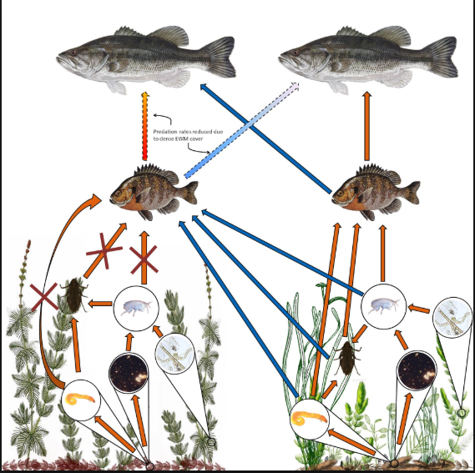

  - Have students investigate the diagram showing how biomass is altered in food webs where mussels are present. Photo Credit
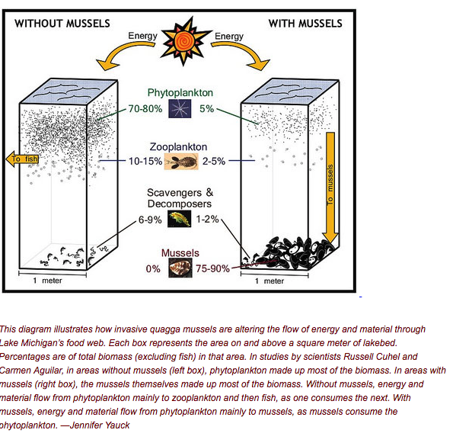
    - What are the mussels eating?
    - How does the mussel affect fish?
    - Why do you think phytoplankton are affected by the mussels more than scavengers and decomposers?

  - Look at the food web with native and rusty crayfish.
    - What would happen if the rusty crayfish were removed?
    - What organism competes with the rusty crayfish?
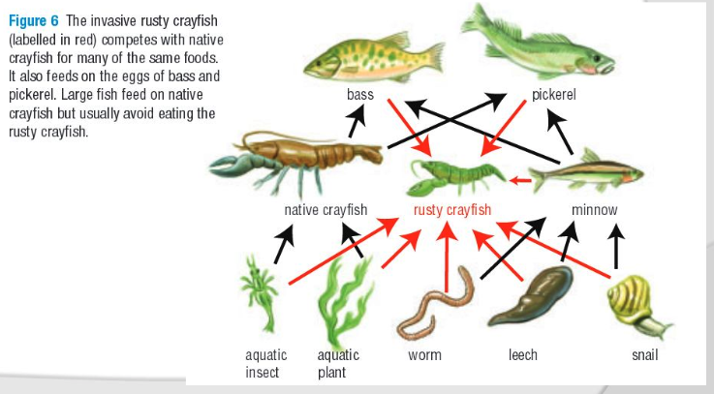

Elaborate - Create a Presentation for the Homeowners Association
- As a group, create a presentation using a slideshow or a poster board that accomplishes the following for the homeowners association:
  - Identify the three featured invasive species: Quagga Mussel, Eurasian Milfoil, Rusty Crayfish
  - Explain how they can harm the lake if they are introduced
  - Provide ways to prevent them from getting into the lake and/or control them if they are introduced to the lake

Evaluate - Create an Infographic for People Using the Lake for Recreation
- The Lake Homeowners Association has asked for an infographic handout to be available for all homeowners and those who use the public dock for recreation when it opens next spring. Individual students will create an infographic handout that gives the same information as the presentation that is single sided, catchy and easy to read.
  - There are several websites that give good information on creating effective infographics. Here are a few:
    - https://piktochart.com/
    - https://designshack.net/articles/graphics/5-key-infographic-elements/
    - https://landt.co/2017/06/the-anatomy-of-an-infographic/

Teacher Resources:
Rubric for Group Presentation
Grading Criteria | Basic  0-5 points | Emerging  6-7 points | Proficient  8-9 points | Advanced  10 points
Description of all three invasive species: Eurasian Milfoil, Rusty Crayfish and Quagga Mussel | Group did not describe the three invasive species | Group identified at least one invasive species | Group identified two invasive species | Group identified all three invasive species
Explains how each invasive species can harm the lake | Group did not explain how any of the invasive species could harm the lake | Group explained how one of the invasive species could harm the lake | Group explained how two of the invasive species could harm the lake | Group explained how all three of the invasive species could harm the lake
Provides at least 3 methods of prevention or control for the focus invasive species | No methods of prevention or control were mentioned | One method of prevention or control was discussed | Two methods of prevention or control were discussed | Three or more methods of prevention or control were discussed

Rubric for Infographic
Grading Criteria | Basic  0-5 points | Emerging  6-7 points | Proficient  8-9 points | Advanced  10 points
Content:  Invasive Species Information | Infographic does not contain any information or pictures on any of the 3 invasive species | Infographic has pictures and information for 1-2 invasive species, but it is minimal and incomplete | Infographic has pictures and information for 2-3 invasive species, some information is missing | All three invasive species are pictured with information about each one
Content:  Invasive Species Prevention and Control | Infographic has no information on prevention or control | Infographic has incorrect or minimal information on prevention and control | Infographic has correct information on prevention and control of 2-3 invasive species | Infographic has correct information on prevention and control of all three invasive species
Creativity:  Color, graphics, layout | Infographic lacks color, has significant whitespace and does not have any eye-catching graphics or numerical data | Infographic has minimal color, some whitespace and a few eye-catching graphics and/or numerical data | Infographic has appealing color, very little whitespace and eye-catching graphics and or numerical data | Infographic is visually appealing with color, effective use of or very little whitespace, several well-placed graphics and significant numerical data.

