Office of Science Lesson Planner (Optional)

Teacher: Maria Siciliano Grade: 5 Science Date(s): Summer 2018
Unit Driving Question: How does an ecosystem work?
Lesson Level Question (If Available):
Plan for success using NGSS: Lessons and assessments should be designed in a way that allows students to engage in all three dimensions simultaneously.
NGSS Performance Expectation(s): | The 3-Dimensions of the Next Generation Science Standards
5-LS2-1. Develop a model to describe the movement of matter among plants, animals, decomposers, and the environment. | Science and Engineering Practices: Eight practices that represent how scientists investigate the natural world. |  | Disciplinary Core Ideas:  Key ideas in science that have broad importance. |  | Cross Cutting Concepts:  Concepts that have connections across all domains of science.
 | SEP: Science & Engineering Practices  Developing and Using Models |  | DCI: Disciplinary Core Ideas  LS2.B Matter cycles between living things in an ecosystem  LS2.B Interdependent Relationships in Ecosystems |  | CCC: Cross-Cutting Concepts:  Systems and System Models A system can by described in terms of its components and their interactions.
Learning Target: (Written in a way that does not give away any scientific discovery opportunities)  Learning Objectives  At the end of this lesson, students will be able to:  - What do plants need to live and what do animals need?  - Explain how the water garden works.  - Compare the water garden to the tanks at the Belle Isle Aquarium.  - Describe how their water gardens are ecosystems. | Academic Language: (Students should discover these terms and concepts through scientific investigations)  Water garden, interdependence, aquatic ecosystem, nutrients |  |  | Materials:  Per class  1 water garden  https://backtotheroots.com/products/watergarden?gclid=CjwKCAjw85zdBRB6EiwAov3RitPQMb8MbXNuKidUSR7wX61_qLyPwqkpCvDaS8m-MK3f3jRjzKXE7hoCbEoQAvD_BwE  Per student  1 cup of rocks  12” cotton string (about the thickness of a mop string and the length of the 2-liter bottle from bottom to top)  1 coffee filter  2-liter bottle – each student needs to bring in. Using scissors, cut off the top 1/3 of the bottle  1 cup potting soil  3-5 grass seeds  1 instructional sheet  1 take-home instruction sheet
 | 3-Dimensional Learning Elements
Phenomena: (Real-world/natural occurrence used to create or support Driving Question Board and connects to each lesson within the unit)  ENGAGE: I will place the water garden in the front of the room. I will explain to the students that I have never cleaned the tank, but it’s not dirty. I have never had to water or fertilize the plants on top, but they are growing. Ask the Guiding Question: How does the water garden work? |  |  |  | Lesson Connection to Phenomena: (How does this investigation help students explain the phenomenon)  I will activate prior knowledge of what plants need to grow, so students make the connection of water having to be involved. Remind the students if they have ever had a fish tank, it gets dirty and you need to clean it, so why not this one? Students will know what an ecosystem is, as they have already been to the Belle Isle Aquarium so they have some knowledge of how the plants help filter the tanks.
Exploration, Discussion, Investigation Activities:
Together with students, write a definition on the whiteboard: An ecosystem includes all of the living things (plants, animals and organisms) in a given area, interacting with each other, and also with their non-living environments (air, water, sun, soil). In an ecosystem, each organism has its own niche or role to play. Show the students the video “Understanding Ecosystems for Kids: Producers, Consumers, Decomposers” prior to starting the exploration task. https://www.youtube.com/watch?v=bJEToQ49Yjc
EXPLORE:
The teacher will ask questions about the aquarium tanks and what we know about how they work
The teacher will ask:
Does our water garden have a complete food chain?
How does that compare to the aquarium?
Students will come up and observe the tank by walking around and looking at all the moving parts.
The teacher will continue to ask questions as students explore:
What do we know plants need to live and what do we know animals need?

After exploring & observing, students will create a hypothesis (working with a partner or small group) for how they think the water garden works. They will write their hypothesis on their instruction sheet or science journal or a whiteboard.

Have all students take out their 2-liter bottles (cut off top one-third at home if possible, otherwise cut them before lesson. Both parts are needed.)
Explain that we are going to construct our own water gardens to help us understand how they work. During the construction process, students can revise their hypothesis if they gain new information.
- Have each student put one cup of rocks in the bottom of their bottles. Ask-- Is this different or the same as our water garden?
- Have each student tie a knot in their string. Have them poke a hole in the bottom of their coffee filter and place the coffee filter in the top of the cut two-liter bottle. Then have them push the string (end without knot) through the coffee filter hole so that it hangs off the bottom.
- Put a cup of soil inside each filter so it fills the top one-third of the bottle. Ask-- how is this part represented in our water garden?
- Plant the grass seeds into the soil in the top one-third of the plastic 2-liter bottle. Seeds should be planted no deeper than the length of the seed.
- Fill the bottom of the two-liter bottle with enough water (4-6”) for a fish to swim in. Make sure the water is room temperature so it doesn’t shock the fish. Place the top one-third of the bottle on top of the bottom two-thirds of the cut 2-liter plastic bottle.
  - Before adding the fish have the students stop and explain how their water garden is similar and different to the classroom water garden? What is the purpose of the string and the coffee filter?
  - Add the fish at the end of the lesson.
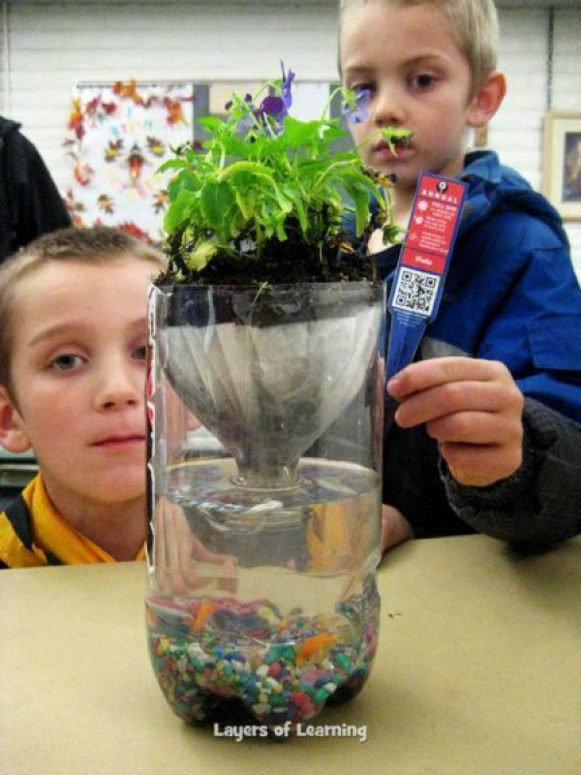
Student’s own water garden (aquatic ecosystem) completely assembled.
EXPLAIN: Students will put their water gardens aside and complete their hypothesis of how they think the water garden works. Students will turn to their table partner and they will explain their ideas to each other.

ELABORATE: Students will then share out their hypotheses about how the water garden works. I will write all the hypotheses shared on the board, noting if we have multiple similar ones. I will continue to ask students to explain their reasoning behind their hypothesis.
I will clarify the small details about nitrates in the water helping the plants.

Supporting students during elaboration: What evidence do you have to support your hypothesis? How do you think the pump in the tank is represented in your water garden? How are the water gardens representing an ecosystem? How are the plants getting water? How does the water where the fish live stay clean? How does the water in the aquarium stay clean?

Differentiation of instruction for exceptional learners: High achieving students could continue advancing their scientific engineering skills by designing another tank or terrarium, to model the interaction of both living and non-living things in an ecosystem, and consider: is it a complete ecosystem?

Formative Assessment(s): (Progress monitoring strategy used to assist with lesson adaptations based on students’ needs)
Student Artifact: (Tangible evidence of student learning)  Students will finish by drawing a model of their own water gardens and labeling the parts and drawing arrows to show the movement of matter and water through the garden. Students must write why they won’t need to water their plants on top. Students also must explain 2 similarities and 1 difference between their water garden and the class’s water garden. |  | Student Discourse: (What you should hear that is evidence of student learning; see Talk Moves)  Why don’t you need to water your plant? Why do you need to feed your fish? How does your water garden represent an ecosystem? How is your water garden similar to the aquarium tanks?
Learning Extensions: (Learning beyond the classroom): Students will be asked to observe or create a water garden at home and to observe how the different parts interact and help one another. Alternatively, ask students to look for organism interactions in other ecosystems around their neighborhood or city.

