FBI - Fighting Bad Invasives
Jessica Wagonmaker Holton Public Schools
& Jessica Vander Ark GVSU College of Education
Lesson overview-In this lesson students will sort invasive species cards in order to categorize them by most dangerous to the environment to least dangerous.
Target- 6th -9th grade
Lesson Objectives
At the end of this lesson, student will be able to:
- Categorize invasive species based on their description and cautions.
- Justify their reasons for placement with convincing arguments.

Source Material
General information about many actual and potential invasive species in the Midwest: https://www.misin.msu.edu/
Additional information about spotted lanternfly: https://www.usnews.com/news/best-states/pennsylvania/articles/2019-04-21/michigan-experts-warn-residents-about-spotted-lanternflies
Additional information about goldfish: https://www.nytimes.com/2016/09/23/science/discarded-goldfish-invasive-species.html

Michigan Science Standards-
- MS-LS2-4 Ecosystems: Interactions, Energy and Dynamics. Construct an argument supported by empirical evidence that changes to physical or biological components of an ecosystem affect populations.
- MS-LS2-2 Ecosystems: Interactions, Energy and Dynamics. Construct an explanation that predicts patterns of interactions among organisms across multiple ecosystems.

List of Materials
Per group of students:
1 set of Ten Most Wanted Aquatic Cards
European Frogbit Asian Carp Northern Snakehead
Zebra Mussels Water Milfoil Phragmites Red Swamp Crayfish
Purple Loosestrife Quagga Mussel Sea Lamprey

1 set of Ten Most Wanted Terrestrial Cards
Autumn Olive Garlic Mustard Spotted Knapweed Mute Swan
Asian Longhorned Beetle Gypsy Moth Emerald Ash Borer
Japanese Beetle Feral Swine Common Buckthorn

Engage examples: Aquatic invasive—Goldfish

Terrestrial example—Spotted lanternfly

Depending on the

FBI-Fighting Bad Invasives worksheet
Focus Question - Which (aquatic or terrestrial) invasive species is the most dangerous to the environment?
5E Lesson Plan
Engage
Teacher shows a picture and presents information about either an aquatic invasive species (e.g., goldfish) or terrestrial invasive species (e.g., spotted lanternfly), as a way of introducing and defining the concept of invasive species and generating a discussion of how an invasive species might be harmful. These two examples are not part of the Ten Most Wanted cards but are ones that students might encounter. They might think about them when they are doing their Ten Most Wanted rankings. Here are “cards” on goldfish and the spotted lanternfly that are similar to the ones used in the Ten Most Wanted:
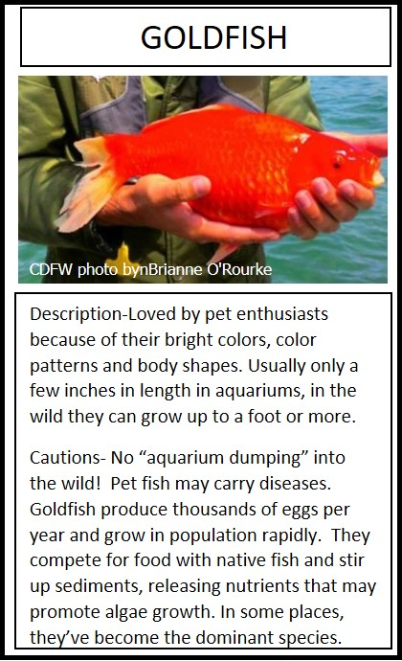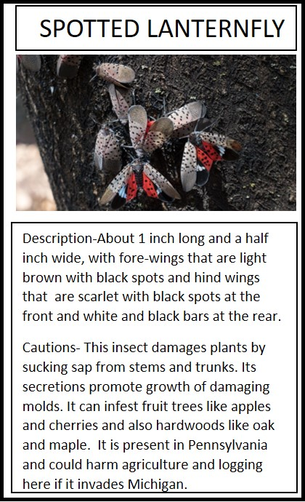
Explore
- Organize students into groups of 3-4 students. Pass out one set of Ten Most Wanted cards. Instruct students to rank each invasive species according to which is most dangerous to the environment, with 1 = most dangerous, and 10 = least dangerous.
- Student groups will discuss the various invasive species and then fill out the FBI 10 Most Wanted worksheet placing each invasive in the chosen order by evaluating the description and cautions.
Explain
For each species, the group needs to write a justification using: Claim, Evidence, Reasoning to explain their choice of rank.

After writing out their rankings and reasoning, the groups of students will explain their findings to the class.

Elaborate
Ask: How will students find or prevent their “Most wanted” invasives in Michigan? For the written assignment, upper grade students should use the individual ranking sheets which have the additional requirement of including ‘a plan for control, mitigation, eradication and prevention.’
Evaluate
Assessment of student learning will be done by evaluating their justification for each ranking on their worksheet and in their presentations.

Group Member Names: ____________________________________________
FBI- Fighting Bad Invasives - Ten Most Wanted Invasives
- Read the Ten Invasive Species Cards, paying close attention to the description and cautions.
- Place the cards in order from Least Dangerous (=10) to Most Dangerous (=1) to the Great Lakes ecosystem. Record the rank and species name in the table below.
- In the last column, the group needs to write a justification using: Claim, Evidence, Reasoning to explain their decisions.

Rank | Name of Invasive Species | Justification for Ranking
FBI- Fighting Bad Invasives - 10 Most Wanted Invasives
Rank #

Group members: ______________________
______________________
______________________
______________________

Justification for Ranking:
______________________________________________________________________________________________________________________________________________________________________________________________________________________________________________________________________________________________________

Plan for Control, Mitigation, Prevention, Eradication:
______________________________________________________________________________________________________________________________________________________________________________________________________________________________________________________________________________________________________

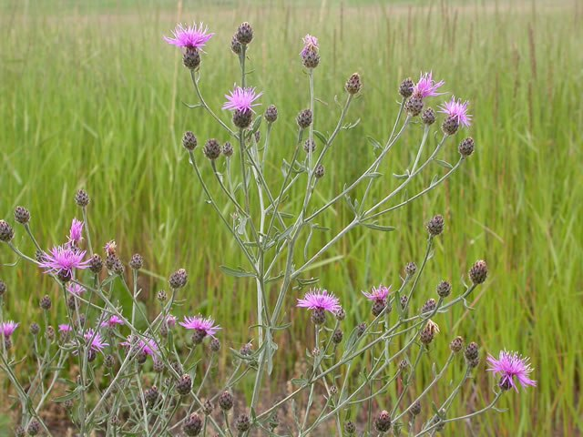
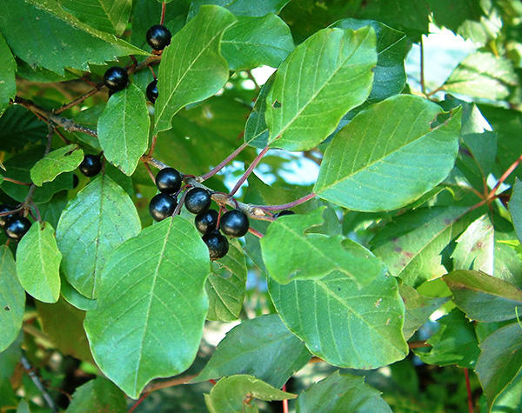
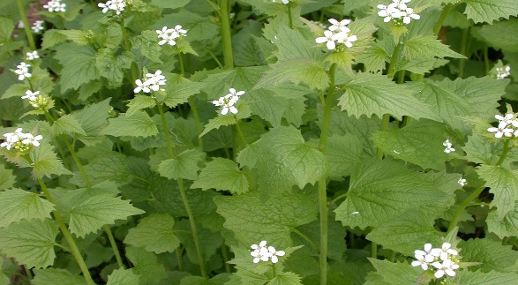
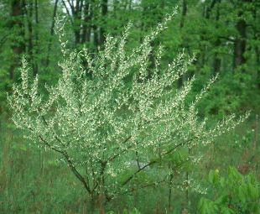
AUTUMN OLIVE
SPOTTED KNAPWEED
Description- Biennial plants with a height up to 6 feet. A single pink-ish purple flower head at end of the stem. The base of the flower is fringed with black tips and short hairs. Grey-green leaves with short think gray hairs.
Cautions- Plants are known to contain toxins that inhibit the growth of neighboring plants found takin over native plants in meadows, pastures and roadsides. Seeds remain viable in the soil for up to eight years.
GARLIC MUSTARD
Description- Autumn Olive is a deciduous shrub that measures 20-30 ft tall. Bark appears to be silver with brownish scales. Leaves are alternate and oval shaped with pointed tips. Leave margins are wavy without teeth.
Caution- This shrub shades out desirable native species and reduced species diversity. It’s growing season is much longer that native plants leafing out in early spring and holding leaves until late fall.
Description-Understory tree with greyish bark and pale horizontal lines. Multiple stems that develop into a single trunk. Opposite leaves that are glossy oval shaped and have tiny teeth. 2-8 small yellow fragrant flowers.
Caution- Common Buckthorn outcompetes with native plants for light. It shades out wild flowers and other understory plants. Preventing natural growth of forest trees and has been known to host agricultural diseases.

COMMON BUCKTHORN
Description- Garlic Mustard is a herbaceous biennial that grows2-4 Ft tall. Leaves are alternate, triangular with large teeth and measure 2-3’ across. Stems and leaves smell like garlic when crushed. Flowers are small, 4-peteled and white in color. Root is a white thin tap root.
Caution- Garlic Mustard invades upland forests, yards and roadsides. It chokes out native plants. This plant also carries antifungal chemical into the soil that disrupts fungi and native plants suppressing their growth., It can re-sprout from the root if only the top of the plant is removed.
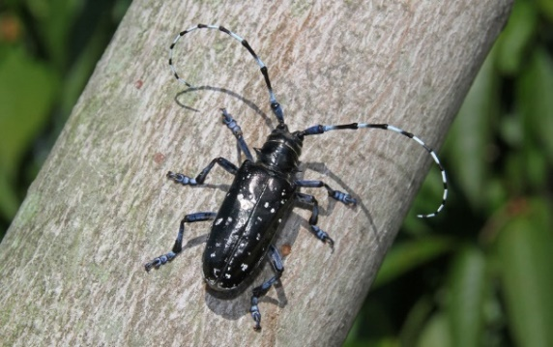
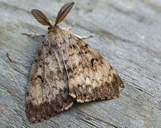
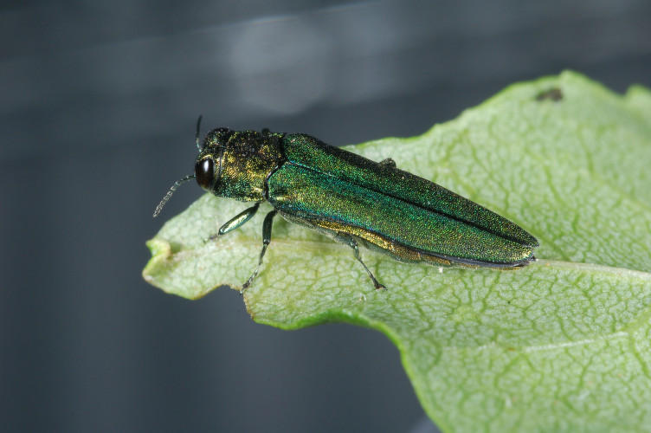
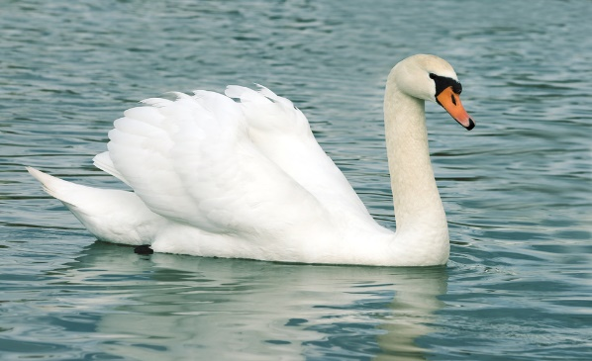
GYPSY MOTH
Description- Adults are less than 5cm long with shiny black exoskeleton containing white spots. Long black and white antennae are longer than the body. Upper sections of legs are white blue.
Cautions- Asian Longhorned Beetle kills a wide variety of hardwood trees including: maple, elms, willows and birches. Damage includes dime-sized holes in trees from where the beetles crawl out of the wood. Long Horned Beetles are spread through movement of infested tree-based materials.
ASIAN LONGHORNED BEETLE
Description- Large aquatic water fowl measuring 49-67 inches in length. Large white plumage with an orange beak bordered with black. A recognizable knob shows on top of the beak.
Caution- Mute Swans build large nests using native vegetation at the edge of a lake. They are strongly territorial birds and will fight for food, shelter and space

Description- Adult beetles are dark metallic-green measuring 1/2” long and 1/8” wide. Grubs are flat, cream colored and have wide heads.
Caution- When an Emerald Ashborer infests a tree, the tree dies. They attack Ash trees by feeding on the layer of the tree’s trunk that lies just below the surface. In doing this, they cut off the flow of nutrients and water to the tree.
EMERALD ASHBORER
MUTE SWAN
Description- Gypsy Moths at adult stages are present in July and August. Males are brown and tend to fly in a zig zag pattern. Females are white and cream and do not fly. Egg masses are cream colored and found on tree trunks, tree branches and sometimes patio furniture.
Caution- Known as North America’s most devastating pests, the Gypsy Moth feeds on the foliage of hundreds of species of plants. When high levels of gypsy moths occur, trees can become completely defoliated. Once defoliated, the tree will die.
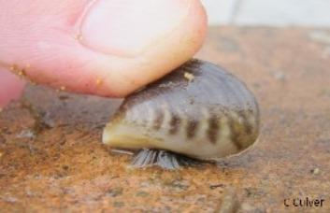
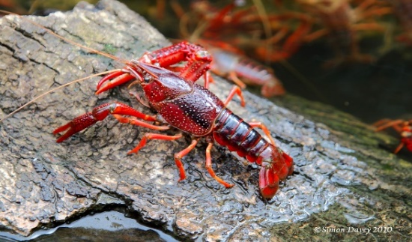
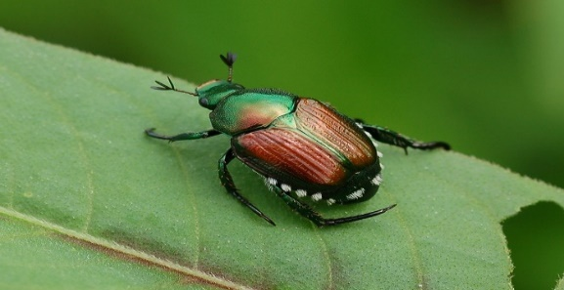
SEA LAMPREY
Description- Adult- 1/3-1/2-inch oval beetle. Metallic green with bronze wing covers. Five patches of shite hairs on each side of the abdomen. Grub is covered with long brown hairs and short blunt spikes. The head is yellowish-brown.
Caution- Japanese Beetle causes damage at all levels of development. Both adult and larvae cause damage to the plant by feeding on the leave surface resulting in skeletonization. Grubs feed on the roots of grasses causing severe damage to pastures, lawns and golf courses. Damaging the roots reduces the plants ability to take in water resulting in dead areas. It also is a pest to several fruit and crop plants with a host range of more them 300 species.
QUAGGA MUSSEL
RED SWAMP CRAYFISH
Description- 1-2 inches, laterally compressed shell has alternating brown to tan-ish stripes. Pale brown near the hinge. Falls over when sat on its ventral surface.
Caution- Mussels can colonize soft and hard surfaces creating mats that cover fish, spawning area, docks, boats and motors. Sharp shells pollute swimming areas and beaches. Commercial and sports fishing in the Great Lakes is threatened by the Quagga Mussel. As filter feeders they filter plankton from the water, disrupting the food web from the bottom up.
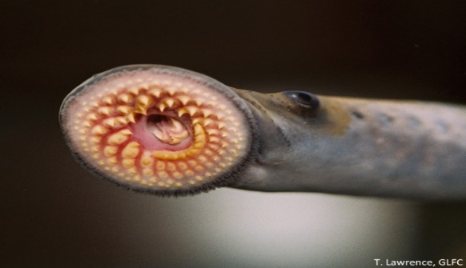
Description- Aquatic crustacean up to 5 inches long (including claws). Dark red body and claws with bright and spiky red bumps. Black wedge shaped stripe on underside.
Caution- Red Swamp crayfish has a diverse diet including: insects, snails, fish, amphibians and plants. This diverse diet can impact an ecosystem. They have been used as food in Louisiana (crawdads), where they are native, but here they compete aggressively with the native crayfish for food and space. In addition, Red Swamp Crayfish can carry fungus plaque and host parasites.
Description- Jawless fish measuring 12-20 inches. Grey-blue back with silver and white belly. They have a suction cup mouth with hook-like teeth and a rasping tongue.
Caution- This fish is a parasitic fish, that kills about 40 lbs. of food it it’s lifetime. One of the most divesting aquatic invasive. They single handedly contributed to the extirpation of lake trout in most of the Great Lakes.
JAPANESE BEETLE
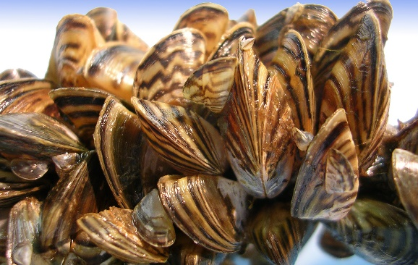
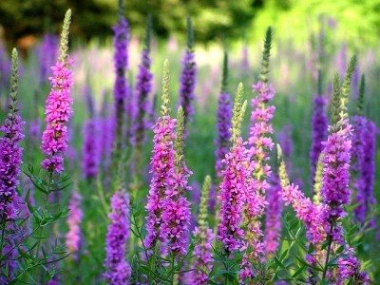
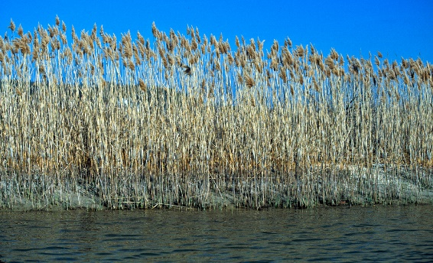
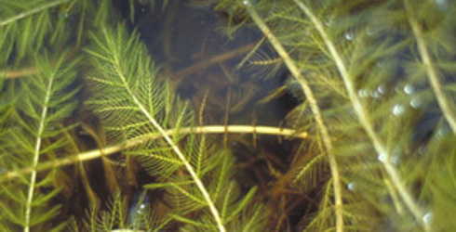
ZEBRA MUSSELS
WATERMILFOIL
PURPLE LOOSETRIFE
Description- Perennial grass with rough stems that grow up to 15 feet. Leaves are blue-green and leaf sheaths are tight on a dull/tan stem. Flowers are bushy purple or gold branching clusters of flowers.
Caution- Phragmites can grow up to 15 feet tall. They grow extremely dense in single-species thickets. These thickets can be as large as 1 square kilometer in size. Phragmites reduce access for fishing, hunting water fowl and swimming. They also block shoreline views.
PHRAGMITES
Description- small size (1-2 inches) black to brownish shell with alternating dark and light stripes (Zebra like). Usually found in clusters of individuals.
Caution- Zebra Mussels attach to hard surfaces generally in shallow waters (6-30 feet). They are a serious problem and can cover boat hulls, motors, piers and drain pipes. Larvae can be drawn into boat motors and take over the interior of the engine. They disrupt the aquatic food web of native fish and smother out native clams and crayfish.
Description- Feathery long steamed branches near the water surface. Forms thick mats in shallow water. Green leaves with 12-21 thin leaflets. Small reddish flowers grow above the water in the midsummer.
Caution- Large amounts of watermilfoil take over shallow areas of lakes and can interfere with fishing, boating, hunting and swimming. Plants can tangle on boat propellers. They can crowd out native plans and impairs the ability for some fish to spawn. It also creates a breeding ground for mosquitoes.
Description- Multiple ridged or square woody stemmed plants. Stems are often fuzzy in appearance. Leaves are opposite stalkless rounded at the base. Magenta-purple colored flower that form a spike. Flowers have 5-7 petals.
Caution- Purple Loosestrife out competes and replaces native grasses, sedges and other flowering plants. It adapts easily to disturbed wetlands and its seeds can remain viable after 2-3 years underwater. Purple Loostrife is responsible for causing a loss of nearly 500,000 acres of wetland each year.
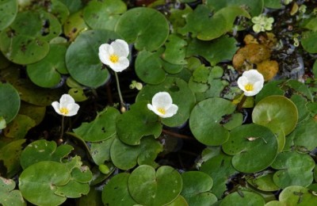
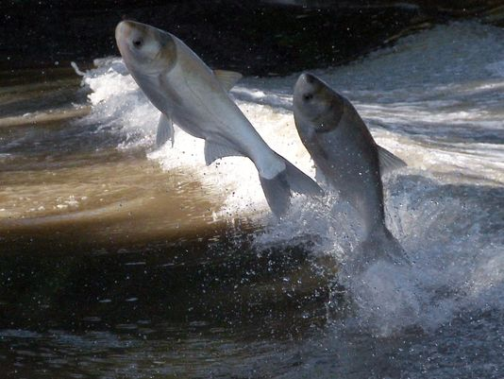
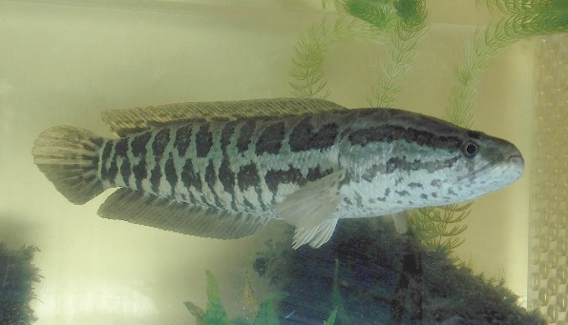
Description- Free floating and can form impenetrable mats at the surface. They have heart shaped leaves that are leathery and spongy with purplish red undersides. They produce a single three peddled white flower about one inch above the water.
Caution- European Frogbit can blanket shallow ponds, marshes and shorelines. These dense layers of plants and hanging roots reduce habitat for native and game fish. This interferes with fishing, boating, hunting and swimming. It also inhibits the growth of native plants.

Description- cylindrical body- up to 47 inches long. Dark brown to tan color with irregular blotches. Long single dorsal fin and long anal fin. Large scales on head give it a “snakehead” appearance. Jaws have canine-like teeth.
Caution-The Northern Snakehead is a voracious top- level predator that feeds on native fish. They have few natural enemies and once established are very difficult to eradicate. Can survive in water with very low oxygen.
Description- Large fish- up to 41 in, 60 lbs. Bright silver sides and a scaleless head, large upturned mouth, eyes set forward looking downward below the midline of the body.
Caution- Asian Carp can leap up to 10 feet out of the water. This poses a threat of serious injury to anglers and boaters. They can reach high population numbers and dominate fish communities. Feeding on plankton, they reduce the amount of food for native fish.
ASIAN CARP

NORTHERN SNAKEHEAD
EUROPEAN FROGBIT

