Protecting our Waterways Design Challenge: Silver Carp
By Jessica Wagonmaker, Science Teacher, Holton Middle School jwagenma@holton.k12.mi.us
Jessica Vander Ark, Western Michigan Environmental Action Council jvanderark@wmeac.org

Lesson Overview This lesson introduces students to the engineering design process-- the process used by engineers to solve design challenges. Students work in small groups to solve the challenge by designing a barrier that would keep Silver Carp from invading a waterway. Students learn about the engineering process by completing an engineering design challenge where they will design and produce a blueprint to solve a problem.
Target Grade Grade level 3-12
Duration Three 45 min class periods
Learning Objectives
At the end of the lesson, students will be able to:
- Explain how the Silver Carp can impact the Great Lakes ecosystem.
- Describe how the engineering design process (EDP) can be used to solve an ecological challenge.
- Draw, discuss and redesign a prototype blueprint.
- Use teamwork and communication to successfully solve a challenge.

List Materials & Quantities
Student worksheets
Protecting Our Waterways Design Challenge - Student Group worksheet
Design Challenge Evaluation Worksheet
Silver Carp Information sheet
Large paper or white board for each group and markers
Poster with steps of engineering design process to post in classroom or student handout
(https://www.sciencebuddies.org/science-fair-projects/engineering-design-process/engineering-design-process-steps)

Focus Question:
What kind of barrier can be constructed to keep Silver Carp out of the Great Lakes?

Classroom Procedures
1. Break class into engineering design teams of four students each.
2. Hand out Silver Carp Information Sheet.
3. Discuss the steps of the Engineering Design Process: Identify the Problem, select best possible solution, construct a prototype, Test the solution, Redesign, Communicate your findings
4. Explain that the students have been assigned to construct a barrier to save the Great Lakes water system from the invading Silver Carp.
They will have one class period to discuss, design and draw a blueprint of their solution. This blueprint should give a detailed explanation of the materials involved and a breakdown of the construction.
5. Provide each team with one piece of 11x17 paper or white board to draw their design and write out their final process. Each group must be prepared to explain their design and process to the class.
They will have one class period to complete the illustration and explanation of the final process as well as prepare their presentation.
6. Student groups present their solution to the class. After the presentation, the class will discuss each solution and give suggestions to the group.
At the conclusion of all the presentations, each group will be given time to redesign their barrier before submitting the finished design.
7. Students fill out the Design Challenge Evaluation Worksheet

Science Standards Addressed https://ngss.nsta.org/DisplayStandard.aspx?view=topic&id=31
MS-LS2-5 Evaluate competing design solutions for maintaining biodiversity and ecosystem services.

Engineering Standards Addressed

3-5-ETS 1-1 Define a simple design problem reflecting a need or a want that includes specified criteria for success and constraints on materials, time, or cost. 3-5-ETS1-1

3-5-ETS 1-2 Generate and compare multiple possible solutions to a problem based on how well each is likely to meet the criteria and constraints of the problem. 3-5-ETS1-2

3-5-ETS 1-3 Plan and carry out fair tests in which variables are controlled and failure points are considered to identify aspects of a model or prototype that can be improved. 3-5-ETS1-3

SEP + CCC + DCIs: https://ngss.nsta.org/DisplayStandard.aspx?view=topic&id=23
https://ngss.nsta.org/DisplayStandard.aspx?view=topic&id=23

MS-ETS 1-1 Define the criteria and constraints of a design problem with sufficient precision to ensure a successful solution, taking into account relevant scientific principles and potential impacts on people and the natural environment that may limit possible solutions. MS-ETS1-1

MS-ETS 1-2 Evaluate competing design solutions using a systematic process to determine how well they meet the criteria and constraints of the problem. MS-ETS1-2

HS-ETS 1-2 Design a solution to a complex real-world problem by breaking it down into smaller, more manageable problems that can be solved through engineering. HS-ETS1-2

HS-ETS 1-3 Evaluate a solution to a complex real-world problem based on prioritized criteria and trade-offs that account for a range of constraints, including cost, safety, reliability, and aesthetics as well as possible social, cultural, and environmental impacts. HS-ETS1-3

The Engineering Design Process
https://www.sciencebuddies.org/science-fair-projects/engineering-design-process/engineering-design-process-steps

Step 1- Identify the problem What is the problem you want to solve?
Step 2- Research the problem What do you already know about the problem? Find out all you can about this problem. What is the criteria or conditions this solution must work into? What are the constraints or issues that could hold back your success?
Step 3- Develop Possible Solutions Brainstorm all solutions to this issue
Step 4- Select the best possible solution Which of your ideas do you think is the best solution?
Step 5- Design a blueprint Draw and label your design
Step 6- Build a prototype Discuss with your group your blueprint.
Step 7-Test & redesign Change your design to make it better.
Step 8- Communicate During each step of the process the team should be in constant communication.

Protecting Our Waterways Design Challenge ~ Student Group worksheet
Team Members: ___________________________________ Group #______

Describe the problem you are trying to address:
Explain what research you have done to find out about this problem:

Draw your design ideas below:

Description of the design and the parts necessary for construction:

Redesign: Did your design solve the problem? If not, brainstorm a new design

Design Challenge Evaluation Worksheet
Student Name: __________________________________________ Group #: ____

- Describe in your own words the problem your group was trying to address:

- Did your solution solve the problem? Explain why or why not

- What went well?

- What didn’t go well?

- What was your favorite element of your design and why?

- If you had more time to redesign, what changes would you make and why?

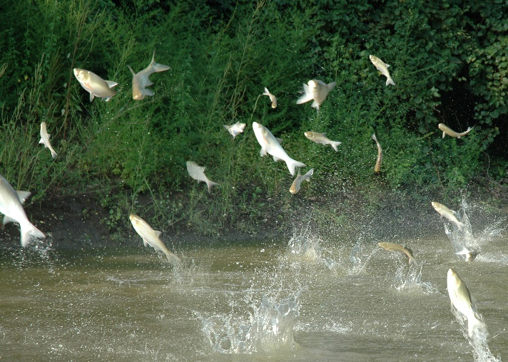
Silver Carp Information Sheet
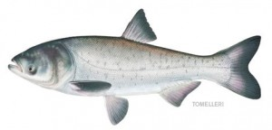

Other common names: Asian Carp, Asian Leaping Carp, Flying Carp, Silver Fin
Description: Large- up to 41 inches, 60 lbs. Olive green with bright silver sides; scaleless head, large upturned mouth, no barbels; eyes set forward below the midline of the body, looking downward; sharp ventral keel from anal fin to throat; known for its leaping ability- up to 10 feet out of the water. Similar in appearance to the bighead carp but lacks the dark blotches on body.
Habitat: Near the surface of calm, slow-moving waters; lakes and backwaters of large rivers
Origin: Native to Eastern Asia; introduced in 1973 in Arkansas with the bighead carp shipments; like bighead carp and black carp, accidentally escaped by flooding; now present throughout much of the Mississippi River basin BUT NOT YET IN THE GREAT LAKES (?).
Spread by: Range expansion; potential bucket transfers
Impact on the Great Lakes: Silver Carp leap in response to the noise and vibration of boat motors, posing a threat of serious injury to anglers and boaters. Sliver Carp can reach high densities following invasion, often dominating native fish communities. They feed mostly on plankton, reducing food for larval fish and filter-feeding fish which include many native fish.
Silver Carp are a danger to native fish species. They are spreading rapidly in the United States, and they are on the federal list of injurious species.
Information source: Invaders of the Great Lakes 2nd Edition
Photo credits: http://www.miseagrant.umich.edu/explore/native-and-invasive-species/species/fish-species-in-michigan-and-the-great-lakes/asian-carp/asian-carp/
http://extension.msstate.edu/news/feature-story/2015/invasive- asian-carp-pose-double-threat

We would greatly appreciate your feedback using this lesson plan! Please visit https://www.biaquariumstem.org/survey.html to complete a short survey about your experience.

