Who am I? Where did I come from? How did I get here?
An invasive species card game

Author: Dr. Jeffrey Ram, Wayne State University
Target Grade/Subject: Grades 5 & 6, Science
Topic: Preventing the introduction and spread of Invasive species

Lesson Overview
Students will learn the names, characteristics, and means of introduction or spread of several aquatic invasive species. They will learn about harmful that these organisms can cause to people or the environment. In small discussion groups, they will focus on the means of introduction and spread and will discuss methods by which the introduction or spread of invasive organisms can be stopped. The lesson utilizes dramatization, reading and listening, discussion, and presentation activities. The activity focuses on a selection of species that people were primarily responsible for introducing into our environment and whose spread or further damage in Michigan might be prevented. Also included are invasive mussels, which have burdened water users with control costs and changed the chemistry of the Great Lakes, and Asian carp, currently established in the Mississippi watershed but might spread to the Great Lakes through canal and river connections.

Background
Invasive species are non-native species that cause economic or environmental harm or harm to human health. Seemingly harmless but careless actions by ordinary citizens have led to harmful invasions by non-native species and the spread of disease to native species. While many invasive species in the Great Lakes, such as zebra mussels, arrived by ballast water which the general public can’t directly do much about, public education can decrease the spread of invasive species, prevent new introductions through pet and other commercial routes, and detect new invaders, even before scientists discover them.

Sources consulted
Wikimedia Commons images and Google images with “tools” set to “labeled for reuse with modification” that can be used for free, with or without attribution.

Selzer, Michelle, Michigan Department of Natural Resources. Presentation titled “Invasive Species in Michigan" posted: (http://detroitaquarium.weebly.com/invasive-species-presentation.html

U.S. Geological Survey. https://nas.er.usgs.gov/queries/factsheet.aspx?speciesid=2265 for information on Northern Snakehead, and all of the other invasive species.

Michigan Invasive Species Information Network http://www.misin.msu.edu/training/

Michigan Departments of Agriculture & Rural Development, Environmental Quality and Natural Resources. http://www.michigan.gov/invasives/

Belle Isle Conservancy. Belle Isle Aquarium website http://detroitaquarium.weebly.com/educating-about-invasive-species.html

Learning Objectives
After this presentation, students will be able to:
- Define ‘invasive species’ and explain how it’s different from non-native or exotic species.
- Describe some of the harmful impacts of several invasive species.
- List several geographic locations where invasive species have come from.
- Give examples of how invasive species have been introduced.
- Explain how invasive species can spread.
- Identify actions that people can take to prevent future introductions of invasive species.

Michigan Science and Social Studies Standards Addressed for Grades 5 & 6
Science
5-ESS3-1 Obtain and combine information about ways individual communities use science ideas to protect the Earth’s resources and environment.
MS-ESS3-3 Apply scientific principles to design a method for monitoring and minimizing a human impact on the environment.
Social Studies
Geography Grade 4 & 6
G5 Environment and Society
Understand the effects of human-environment interactions.
4 – G5.0.1 Assess the causes and positive and negative consequences of human activities in different parts of
the country (e.g., agriculture, forestry, urban, [recreation], and suburban development)
G5.1 Humans and the Environment
Describe how human actions modify the environment.
6 – G5.1.1 Describe examples of how humans have impacted and are continuing to impact the environment
in different places as a consequence of population size, level of consumption, and technology.

List of All Materials Needed
- Cards for the invasive species card game “Who am I? Where did I come from? How did I get here?”
- Instruction page for the invasive species card game, showing pictures and information on the 8 invasive species on the game cards. This page has background information for teaching and could also be copied for each student as reference material.
- A global map and/or map of the United States. (Optional)

Room Arrangement or Special Needs
A classroom with a whiteboard. Write the names of each of the 8 species in the game on the board

Focus Question(s)
What is an invasive species?
What harm do invasive species cause?
How do invasive species get here and what can I do to prevent more of them?

New Vocabulary
Native species: plants and animals that normally live and thrive in a particular ecosystem, and developed with the surrounding habitat.
Invasive species: non-native species that cause economic or environmental harm or harm to human health.
Note: Not all non-native species cause harm; those that don’t cause harm to economics, environment, or human health are not considered invasive species.
Ship ballast: water that is pumped into or out of special tanks on large ships that keep the ship floating at just the right depth in the water no matter how much cargo is on board.
Names of specific invaders—see the names on the cards

CLASSROOM PROCEDURE
Introduction
The lesson assumes that students have previously learned about species normally found in their area and how they relate to one another through food webs and ecosystems, which this lesson reinforces and supports through discussions of what happens when those systems are disrupted.

Introduce the concept of invasive species. Ask students if they’ve heard of invasive species? Ask students to share their ideas of what they are. What are the criteria for an invasive species?

An invasive species is a non-native species that causes economic or environmental harm or harm to human health.

Tell class that they will play a game that will introduce them to several invasive species that are of concern in the Great Lakes. They will have fun learning the names of some invasive species, will learn about the harm they cause, and will discuss ways in which invasive species can be reduced or prevented in the future.

Card Game Set-Up
Mix the cards well and distribute one per student. There are 24 cards. If you have fewer than 24 students, remove 3 or 6 cards with matching numbers, to reduce the number of cards to 21 or 18. If you have more than 24 students, some students will have to double up on individual cards.

Write the names of the 8 species of the game on the whiteboard. The students will be guessing the species name based on a charade by one of the students. Note: our experience is that the charades that students or adults do to express the names are based on acting out the familiar parts of words or sounds in the names, not necessarily by acting out what the harmful animal does (e.g., an example is behaving like a bird to elicit “parrot feather watermilfoil,” which is actually a plant!). Having a list of the names is sufficient for this charade to be a fun activity for reinforcing the names and types of animals or plants of most of these invaders. The list on the board are the clues to what the possible choices are. You might want to indicate which ones are fish and plants since some of these unfamiliar names don’t indicate the type of organism they are (e.g. what is a “Northern snakehead”?).

Activities
The game consists of two parts, to which additional cross-curricular activities can be added. Part 1 can be done on one day (about 3 min per species; total 25 min). Part 2 can be done the same day (10 min for breakouts and 15 min for report back, total 25 min) or the next day, with additional cross-curricular activities.

Part 1
A “Who am I?” game in which students with cards showing organisms are asked to do a charade or other activity and the rest of the class guesses the name of the organism that is being “acted out.” This helps the students learn the names of the organisms. After the student’s organism is identified, ask “Who has the description card of this invader?” The student with the matching “description” card joins the student who did the charade and reads the information on the card “Why bad?”, “Fun fact”, “Where did I come from?” At this point, the teacher may guide a short discussion to reinforce the information on the card (e.g., relating “Why bad?” to previous lessons on food webs), after which the student is requested to give the number on the card and ask: “How did I (or will I) get here?” The student with the matching “source” card (identified by the matching number in the corner of the card) describes the method of introduction or spread. (25 min.)

Part 2
When all or most of the species on the cards have been introduced and students have formed groups by the above activities, the eight groups have breakout discussions on ways that introduction or spread of their organism or others like it could be stopped. Groups then report back on their idea (specifically: K-ESS3-3 Communicate solutions that will reduce the impact of humans on the land, water, air, and/or other living things in the local environment.). (25 min.)

Cross-curricular activity extensions:
- On a global map, mark where the eight invasive species on the card have come from. This could be done on day 1 of the activity, as the description cards are read.
- Write a report based on research about other invasive species. Each student (or groups) is assigned to research additional invasive species on the Michigan aquatic invaders watch list and to write reports containing information similar to the card game: a photo of the invader; description including why harmful to people, environment, or the economy; sources and means of invasion or spread; and proposed best responses.
- Create educational materials about invasive species, such as a “public education poster” or more cards for the game.

Assessment of Student Learning
Ask students the following questions:
- Name and describe characteristics of at least five invasive species of concern in Michigan.
- Describe the harm that invasive species have caused to other organisms, people, or the economy, supporting their descriptions with specific examples of invasive species and the types of harm they cause.
- Give examples of three ways that invasive species are introduced.
- Describe three ways that invasive species can be reduced.

Take Home Handouts, Materials, or Resources
Students knowledge can be reinforced by looking at the invasive species activities and information on the Belle Isle Aquarium web site:
http://detroitaquarium.weebly.com/kids-corner.html , and
http://detroitaquarium.weebly.com/educating-about-invasive-species.html

Cleanup
Gather all cards and reorganize for the next group.

Safety considerations
None

Invasive species—a threat to the Great Lakes
Card game: Who am I? Where did I come from? How did I get here?
Invasive species are non-native species that cause economic or environmental harm or harm to human health. Seemingly harmless but careless actions by ordinary citizens have led to harmful invasions by non-native species and the spread of disease to native species. While many invasive species in the Great Lakes, such as zebra mussels, arrived by ballast water which the general public can’t directly do much about, public education can decrease the spread of invasive species, prevent new introductions through pet and other commercial routes, and detect new invaders, even before scientists discover them.
The pictured species are a few that people were primarily responsible for introducing into our environment or whose spread or further damage in Michigan might be prevented. Also shown are invasive mussels, which have burdened water users with control costs and changed the chemistry of the Great Lakes, and Asian carp, currently established in the Mississippi watershed but might spread to the Great Lakes through canal and river connections.
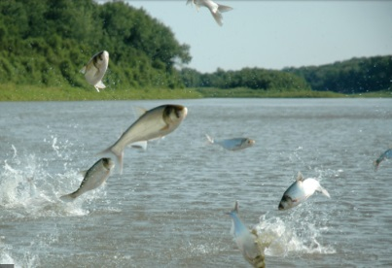
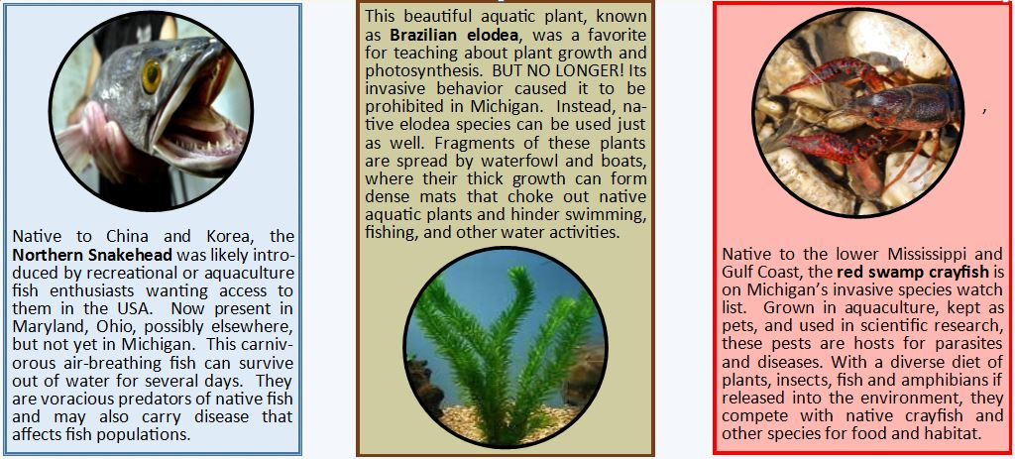
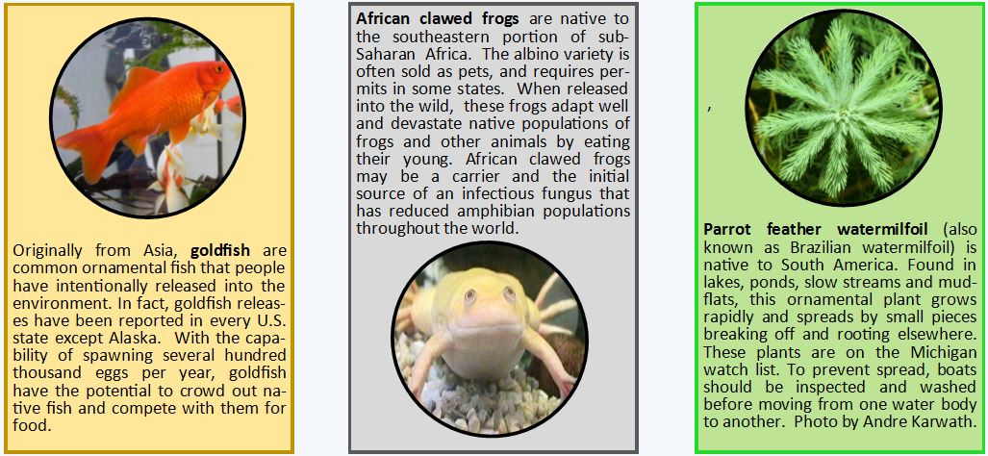
Several species of Asian carp were introduced from China into south-ern USA aquaculture ponds, but they escaped into the Mississippi watershed due to flooding. Having spread up the Illinois and Wabash Rivers, they are now threatening to invade the Great Lakes through water connections near Chicago and in Indiana. They filter algae from the water, competing with native fish. Silver carp jumps when disturbed and has been known to injure boaters. An electric barrier near Chicago may prevent or slow their entry into the Great Lakes.
Zebra mussels and quagga mussels come from southeast Russia and Ukraine. Likely transported here in ship ballast they invaded the lower Great Lakes first, and spread through water connections and attached to boats and trailers to the Mississippi watershed, and west to Lake Mead in the western USA. They filter plankton out of the water; settle in water intakes of power plants, and on native species. Have changed the chemistry of the Great Lakes.

Game play: Write the names of all eight organisms on your whiteboard. Deal out cards one per student (share a card if necessary). Select a student with an “organism” card to do a charade or other activity to answer “Who am I?” After the student’s organism is identified, ask “Who has the description card of this invader?” The student reads the card and pairs up with the student having the organism card. Repeat with other cards, or just pair up without the “Who am I?” part of the game. (Numbers on the cards can help make the right pairs if you don’t do it by the “Who am I?” identification procedure). Then ask “How did I get here?” and add the student to the matching group that has the method that may spread the organism to the Great Lakes. These groups of three students then form “breakout groups” for 5 to 10 minute discussion of “How could we prevent this organism from spreading further?” and then report back. Answers could be personal actions (don’t buy that pet! Dispose of pets or classroom organisms properly if no longer wanted.), or possibly new public policies—laws or regulations restricting what can be sold to whom, controlling how ships handle ballast, etc. In some cases more than one means of spreading might apply, but if you are guided by the card numbers, you will get the best grouping of cards. Printing cards: Pdf file available at http://detroitaquarium.weebly.com/invasive-species-card-game.html . You can print the pdf cards file on Avery 5390 “name badge insert refills,” an available office supply, or print on cardstock and cut.
Production of this card game is funded in part by a grant from the Michigan Invasive Species Grant program through the Departments of Natural Resources, Environmental Quality, and Agriculture and Rural Development.

We would greatly appreciate your feedback using this lesson plan! Please visit https://www.biaquariumstem.org/survey.html to complete a short survey about your experience.

